azFinance Loan Fee Structures

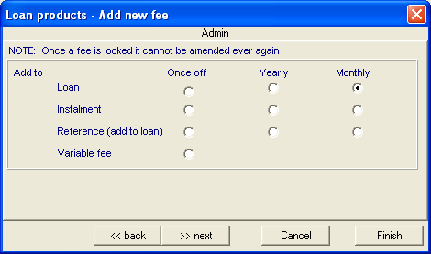

Once-Off

Loan
The fee is charged upfront on inception of the loan.

Instalment
The fee is charged once but spread over the period of the loan.

Example
A loan of R1000.00 taken over a period of 3 months and incurring a R300.00 Once-off monthly fee would create a monthly fee of R100.00 (R300.00 / 3).

The fee is charged on the first instalment date and not on the proceeding instalment days.

Reference (add to loan)

Variable fee

Yearly

Loan
This fee is setup as an annual amount. The system then calculates this amount as a monthly figure calculates the total amount to be paid across the entire loan period and capitalises that amount upfront on the inception of the loan.

Example
A loan of R1000.00 taken over a period of 3 months and incurring a R120.00 yearly fee would create an upfront fee of R36.00 (R120.00 / 12 * 3).

Instalment
This fee is setup as an annual amount. The system then calculates this amount as a monthly figure which it charges every month on instalment day.

Example
A loan of R1000.00 taken over a period of 3 months and incurring a R120.00 yearly fee would create a monthly fee of R12.00 (R120.00 / 12).

Reference (add to loan)

Monthly

Loan
The fees payable over the entire contract of the loan are calculated and financed upfront.

Example
A loan of R1000.00 taken over a 3 month period and incurring a 10% monthly fee would create an upfront fee of R300.00 (R100.00 * 3).

This fee must then be linked to a Code 15 transaction type in order to be taken into account.

Instalment
The fee is capitalised on a monthly basis on instalment day.

Example
A loan of R1000.00 taken over a 3 month period and incurring a 10% monthly fee would generate a monthly of R100 added to the account on instalment day.

